**NETWORKING & SYSTEM ADMINISTRATION LAB** 

**Experiment No.: 5**

**Aim**

Familiarization of basic commands

**Procedure**

1. **CP**

**cp** stands for **copy**. This command is used to copy files or group of files or directory. It creates an exact image of a file on a disk with different file name. *cp* command require at least two filenames in its arguments.

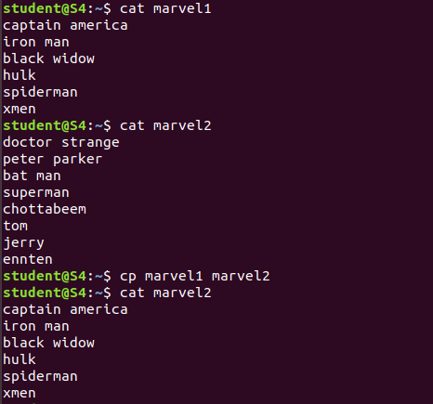

Options:

Cp -r:Option **'r'** with the copy command can be used to copy a directory including all its content from a source directory to the destination directory.

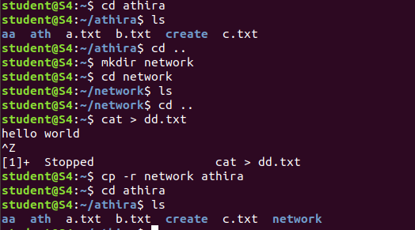

cp -i:The cp '-i' option allows you to confirm once before overwriting your file.

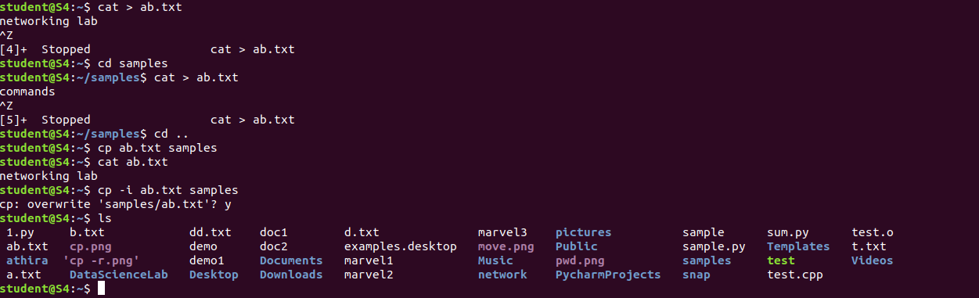

1. **MV**

**mv** stands for **move**. mv is used to move one or more files or directories from one place to another in a file system.

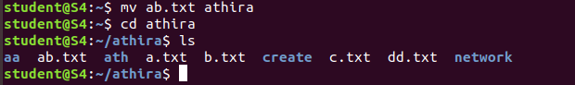

**mv -i:** this command is used to move one directory to another directory.

